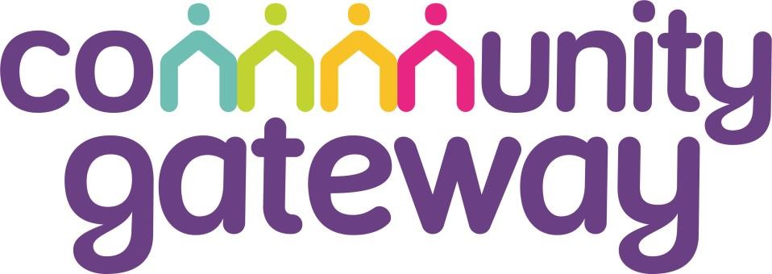

BOARD MEMBER QUALITIES FRAMEWORK

Introduction

The aim of this quality framework is to enable CGA’s Board to evidence performance at the highest level, in alignment with CGA’s wider vision and values and in accordance with Regulatory Standards.

It is anticipated that this framework will inform future Board and Committee member recruitment and selection, appraisal and learning and development.

The following are the qualities and behaviours CGA will require from Board and Committee members, as we continue to develop services and homes for our customers in a higher risk environment and under an ever evolving regulatory regime.

Such personal behaviours and qualities, when well developed, will enable individual Board and Committee members to maximise their contribution to the governance structure, ensuring better debate, challenge and decision making. This should ultimately lead to better strategic planning and most importantly for all, value for our tenants and wider stakeholders.

|  |  |  |  |
| --- | --- | --- | --- |
|  | **Quality** | **Leadership** | |
|  | **Definition** | The extent to which a Board and Committee leads and motivates an organisation influences its success and is a key indicator of effective governance. Within a Board and Committee, effective leadership from the Chair is equally important. | |
|  | **Positive Indicators** | | **Negative Indicators** |
| •  •  •  •    •  • | Understands and consistently demonstrates and reinforces the vision and values of CGA    Actively promotes the interests of CGA outside the organisation    Understands and is able to explain how Board and Committee decisions support CGA’s short, medium and long term objectives    Demonstrates high standards of ethics and integrity and leads by example  Inspires others to give their best and supports the development of an effective  Board/Committee    Able to make independent and critical judgements | | * Doesn’t understand and/or demonstrate the vision and values of CGA      * Is reluctant or unwilling to be an ambassador for CGA        * Is unable to explain how decisions link to CGA’s objectives      * Doesn’t seek to inspire others and create a shared vision for the future      * Doesn’t listen to others and value their opinions      * Fails to be accountable for decisions and does not take ownership for resolving problems      * Over reliant on the views and opinions of others when making judgements and reaching decisions |
|  | **Quality** | **Team-working and Communicating Effectively** | | |
|  | **Definition** | As part of an effective Board and Committee, it is important that a team member can communicate effectively with a wide range of people. | | |
|  | **Positive Indicators** | | **Negative Indicators** | |
| •  •  •  •  •  • | Reaches a conclusion based on a rational interpretation of the available information    Compromises where appropriate and takes collective responsibility for decision making    Acts as a team player to add value, offering both support and challenge to colleagues, whilst respecting others inside and outside of meetings    Recognises the strengths and contributions of other Board members    Actively contributes to the effectiveness of the  Board and Committee    Able to solve problems, identify and navigate through potential conflicts to build effective relationships with colleagues | | * Jumps to conclusions without fully considering all available information     ● Fails to take collective responsibility for decision making and is unwilling to seek a consensus     * Is negative about the contribution of others and dismissive of their views and opinions      * Lacks trusts in others      * Avoids resolving conflict, or resolves subjectively      * Is unable to flex their natural style to suit the situation | |

|  |  |  |  |
| --- | --- | --- | --- |
|  | **Quality** | **Influencing and Constructively Challenging** | |
|  | **Definition** | Board and Committee decision making is usually done by consensus and influencing skills play an important part. The ability to challenge constructively is also crucial as the Board and Committee needs to maintain good working relationships while fulfilling its supervisory role. | |
|  | **Positive Indicators** | | **Negative Indicators** |
| •  •  •  •  •  • | Challenges freely and constructively without appearing aggressive    Influences others through persuasive discussion    Not afraid to express opinions that contradict those of others    Works collaboratively to reach consensus decisions; respects and supports collective decisions made by the Board    Able to identify strengths and weaknesses in their own and others points of view    Challenges established thinking to ensure long term value and sustainability | | * Is reluctant to constructively challenge others or takes challenges personally      * Is closed or defensive      * Afraid to voice their opinion or challenge the views of others      * Is unable to accept a degree of compromise in order to reach consensus decisions      * Lacks self-awareness and does not seek to identify strengths and weaknesses in their opinions and those of others |

|  |  |  |
| --- | --- | --- |
| **Quality** | **Analysing and Scrutinising** | |
| **Definition** | A key role of the Board and Committee is to monitor the organisation’s performance, requiring effective analysis of information in various formats. Board and Committee members also need to seek out information, giving them the context within which to knowledgably and confidently assess performance. | |
| **Positive Indicators** | | **Negative Indicators** |
| * Actively seeks facts, data and information necessary to ensure performance delivery and management of risk is in line with our risk appetite      * Analyses data to determine key issues, identify gaps, and is able to draw appropriate conclusions from complex information      * Self-confident enough to have a willingness to ask naïve questions and explore issues      * Able to balance the needs and desires of residents with pressures on the organisation      * Able to ask pertinent questions that are relevant to the topic      * Keeps to the appropriate level of detail | | * Does not consider CGA’s Corporate Strategy when making decisions      * Uses an ineffective approach to problem solving      * Formulates conclusions before considering the evidence      * Settles for the satisfactory solution rather than the optimum solution      * Does not ask relevant questions or clarify when uncertain about an issue.      * Becomes too absorbed in the detail and does not consider the bigger picture |

|  |  |  |  |
| --- | --- | --- | --- |
|  | **Quality** | **Directing Strategy** | |
|  | **Definition** | An essential element of a Board and Committee member’s role.  Effective performance in this area means that a Board or  Committee member adds value to the organisation’s framework for setting future plans and action. | |
|  | **Positive Indicators** | | **Negative Indicators** |
| •  •  •  •  •    • | Actively contributes to setting, prioritising and monitoring delivery of strategic objectives    Able to take a broad overview, taking into account all relevant factors, when considering organisational strategies    Is mindful of the need to be aware of the longterm implications of any strategic plan    Applies specialist knowledge and skills appropriately to add value to strategic plans.    Brings knowledge of environmental scanning into debate – is aware of trends and developments internally and externally  Evaluates risks and likely outcomes when reaching decisions and shows a willingness to take calculated risks | | * Makes little or no contribution to setting, prioritising and monitoring of strategic objectives      * Focuses on aims that have little business return or that do not align with organisation’s strategic objectives      * Only focuses on the short-term and does not consider the long term implications      * Does not actively use their specialist knowledge and skills to influence and improve strategic plans      * Is too internally focussed and fails to consider how external influences may impact on the organisation’s future      * Does not effectively evaluate risks and is either too risk averse or is prepared to take risks which could have a serious detrimental impact on the organisation’s viability. |

|  |  |  |  |
| --- | --- | --- | --- |
|  | **Quality** | **Customer Focus** | |
|  | **Definition** | A key goal for CGA is to enhance housing provision and customer services. The Board and Committee, therefore, need to ensure that the requirements and priorities of customers remain high on the agenda. | |
|  | **Positive Indicators** | | **Negative Indicators** |
| •  •  •    •  •    • | Shows constant awareness of the customer as a primary business driver    Demonstrates a clear tenant perspective and an ability to understand and articulate tenants’ needs; overseeing the implementation of strategies, policies and procedures designed to best meet those needs    Champions the Gateway model and the voice of tenants  Is in touch and up to date with the views and aspirations of CGA’s customers    Creates and develops strong mutually beneficial working relationships with strategic partners and other stakeholders  Champions equality and diversity and seeks to ensure that the organisation contributes to community cohesion | | * Does not recognise customers as a primary driver of business strategy      * Lacks understanding of tenants’ needs      * Does not act as an ambassador for the   Gateway model and the voice of tenants     * Does not keep up to date with the views of our customers or take account of these when reaching decisions      * Does not engage with partners and stakeholders to build strong working relationships and promote CGA      * Is dismissive of the need to champion diversity and build cohesive communities |

|  |  |  |  |
| --- | --- | --- | --- |
|  | **Quality** | **Self Management and Development** | |
|  | **Definition** | It is imperative that a Board and Committee member takes ownership of their own personal development and commits fully to the role they have been given. | |
|  | **Positive Indicators** | | **Negative Indicators** |
| •  •  •  •  •    • | Demonstrates enthusiasm and commitment to their role - prepares in advance, regularly attends and participates fully in Board and Committee meetings    Participates fully in appraisals and Board and Committee effectiveness reviews    Takes personal responsibility and encourages others to do the same    Governs – recognises the strategic role of a Board Member and does not seek to manage or get involved in operational activity    Is passionate about continuous learning to develop effectiveness as a Board and Committee member  Treats people with respect, actively promotes equality and diversity and challenges inappropriate behaviour | | * Appears to lack enthusiasm and commitment for their role - does not prepare in advance or attends irregularly impacting on their ability to participate effectively.      * Is an unwilling or reluctant participant in appraisals and Board/Committee effectiveness reviews      * Unwilling to take personal responsibility and be held to account for their action/inaction.      * Has a tendency to become too involved in operational issues.      * Doesn’t see the need to develop themselves, does not value feedback and is not receptive to learning and development opportunities      * Lacks respect for others, does not value equality and diversity or doesn’t challenge inappropriate behaviour |

|  |  |  |  |
| --- | --- | --- | --- |
|  | **Quality** | **Partnerships and Relationships** | |
|  | **Definition** | An effective Board and Committee member should be committed to building partnerships and relationships which support the delivery of CGA’s vision. | |
|  | **Positive Indicators** | | **Negative Indicators** |
| •  •  •  •  • | Readily attends external events as a CGA representative    Is a strong ambassador for CGA, acting responsibly and appropriately when representing  CGA at external events    Builds and maintains constructive working relationships with other Board Members, Officers and relevant stakeholders    Demonstrates an awareness of the role of stakeholders and partners and their value to CGA    Develops networks to improve their knowledge and share best practice | | * Does not attend/is reluctant to attend events as a CGA representative      * Fails to be an ambassador for CGA and does not represent themselves or CGA in a positive way at external events      * Struggles to build and maintain constructive working relationships with others      * Lacks awareness of the role of partners/stakeholders and fails to recognise how CGA can work with partners to achieve its objectives      * Is insular and doesn’t seek to develop networks |